University of Engineering and Technology, Lahore
Name: Maria Abbas
Reg No: 2026(S) CYS_61
Department: Computer Engineering
Degree: Cyber security
Section: B
Assignment: PF Lab week 8
Date: 4 May 2026
CLO3

Lab Tasks
Sets and Dictionary
Sets:
Task 1:
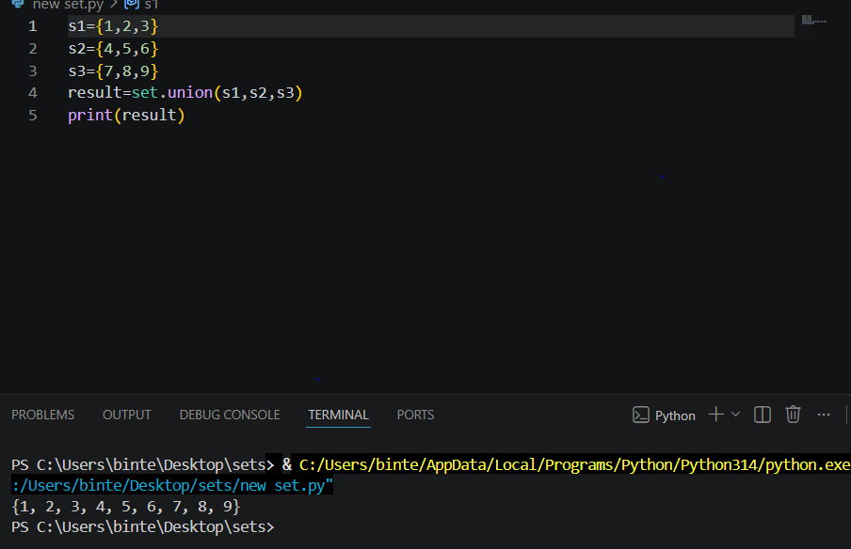
Task 2:
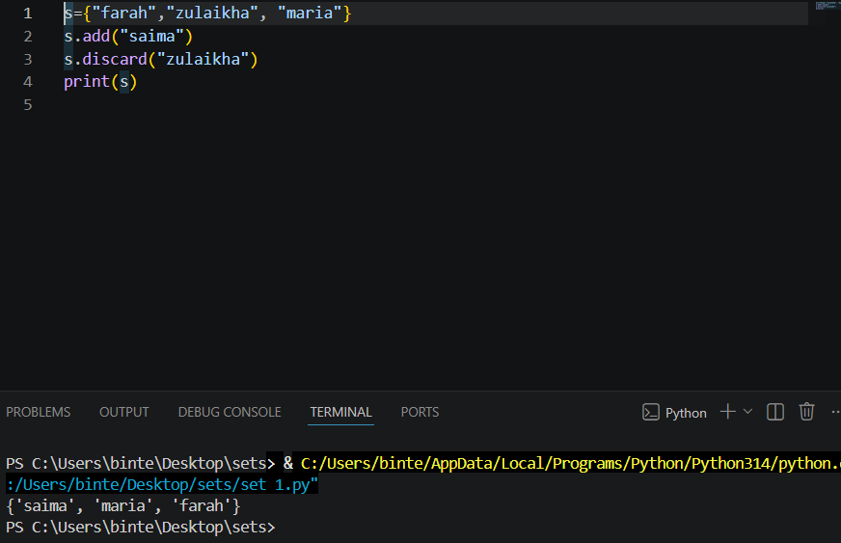
Task 3:
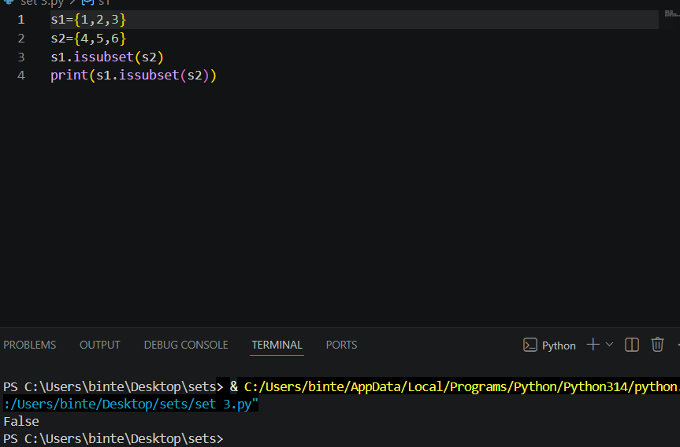
Task 4:
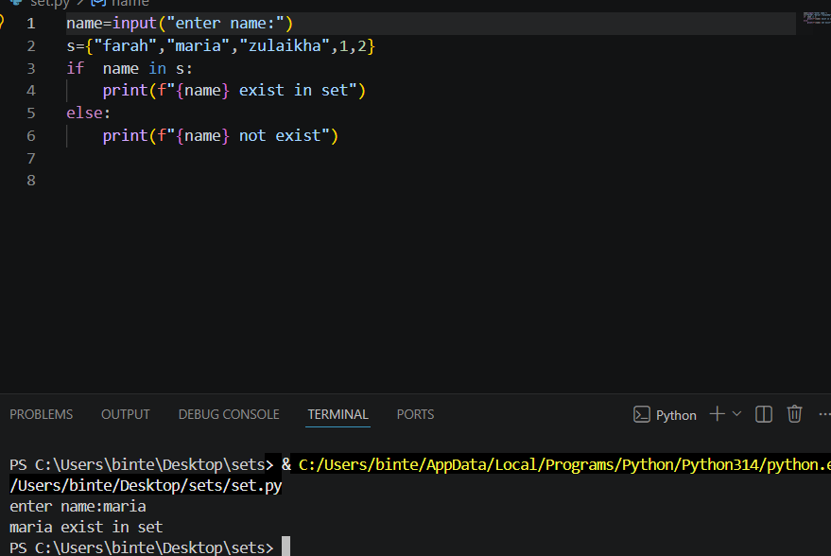
Task 5:
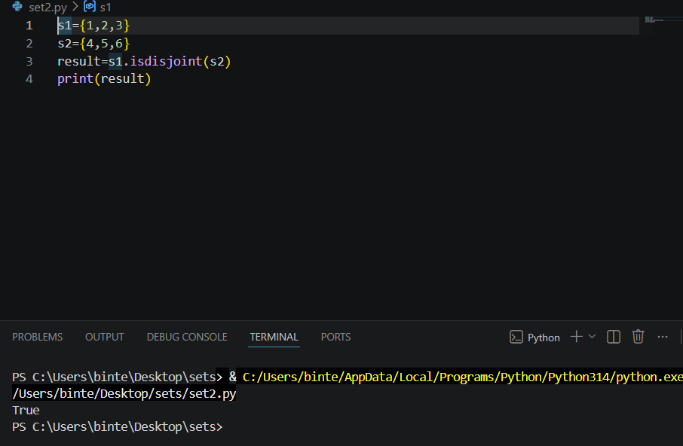
Task 6:
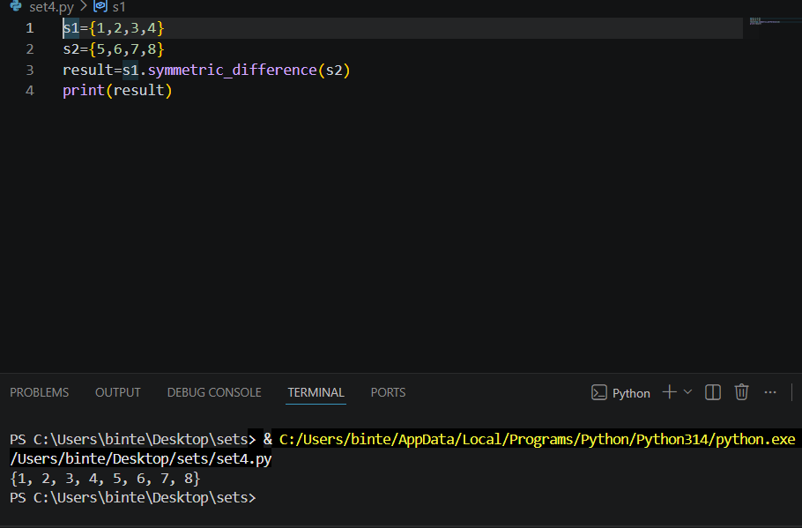
Task 7:
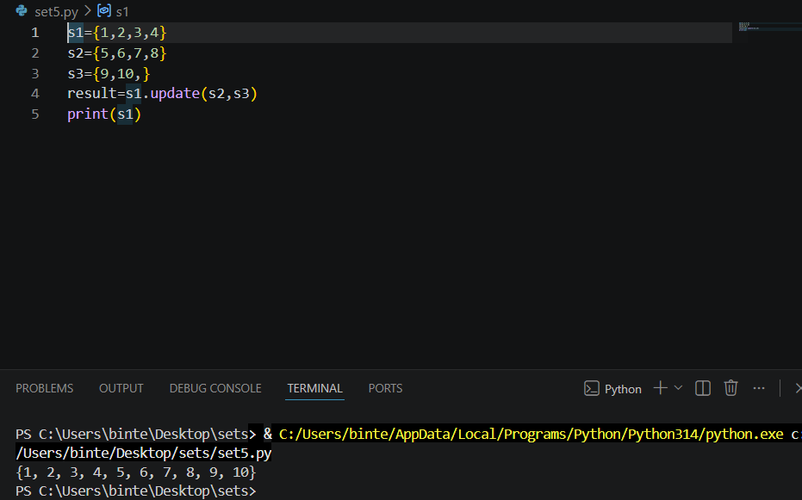
Task 8:
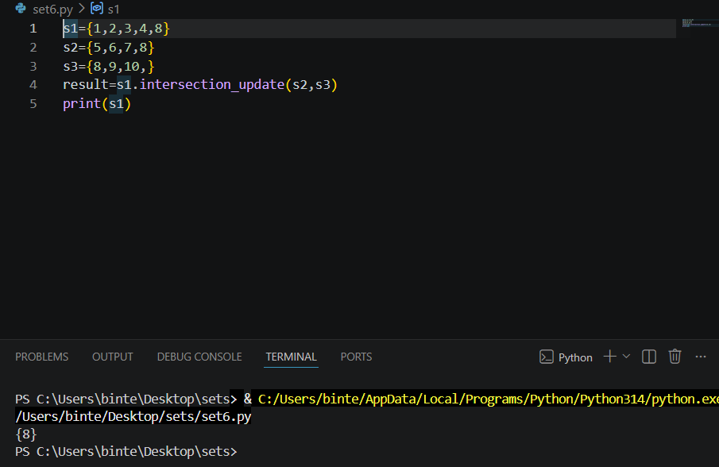
Dictionary
Task 1:
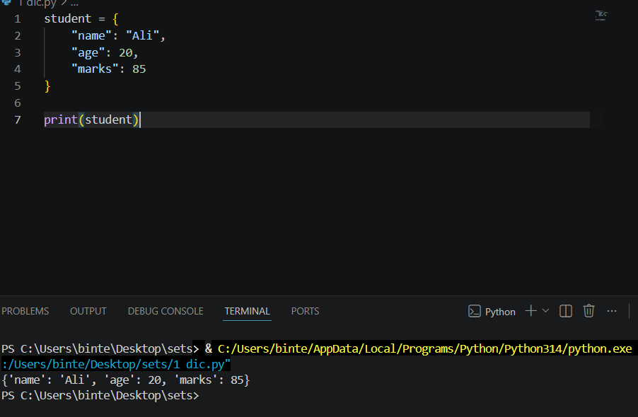
Task 2:
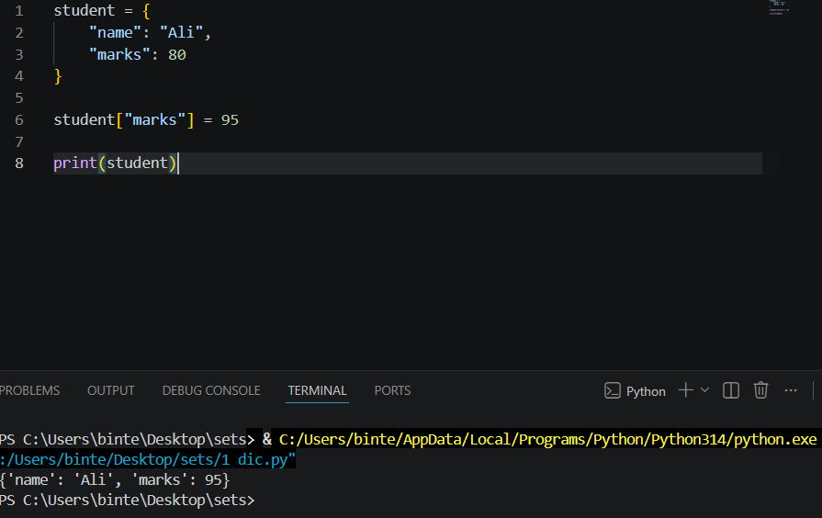
Task 3:
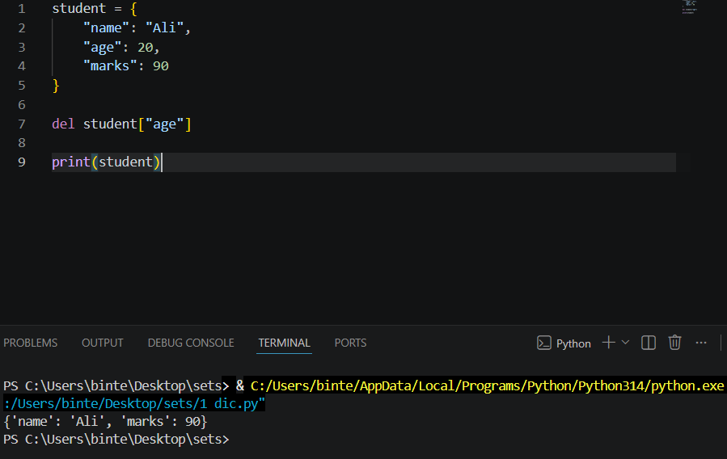
Task 4:
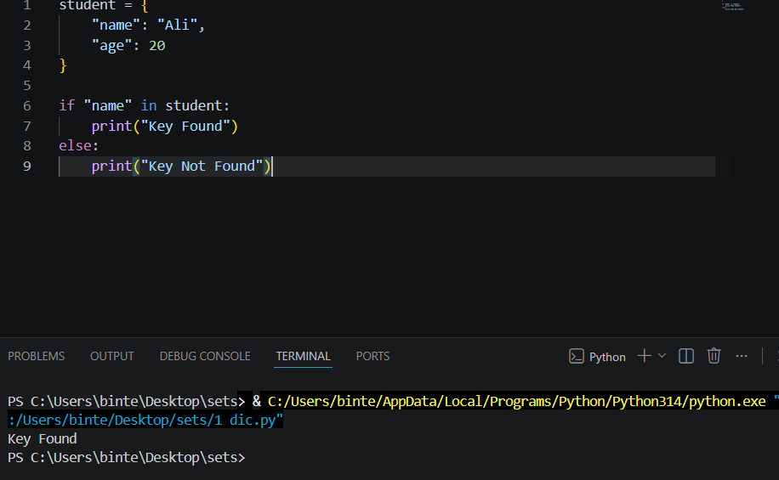
Task 5:
